# 

**The blue and yellow represent Legacy Pointe's colors, and the green (growing higher) represents the continuing growth provided by our residents. By Jonathan Wahl**

**FEBRUARY 2024**

**Happy Birthday to the LP Independent Times**

**We have finished year number one of our ‘Times’**

**This edition starts year number two**

# Our Day Begins – Here comes the sun

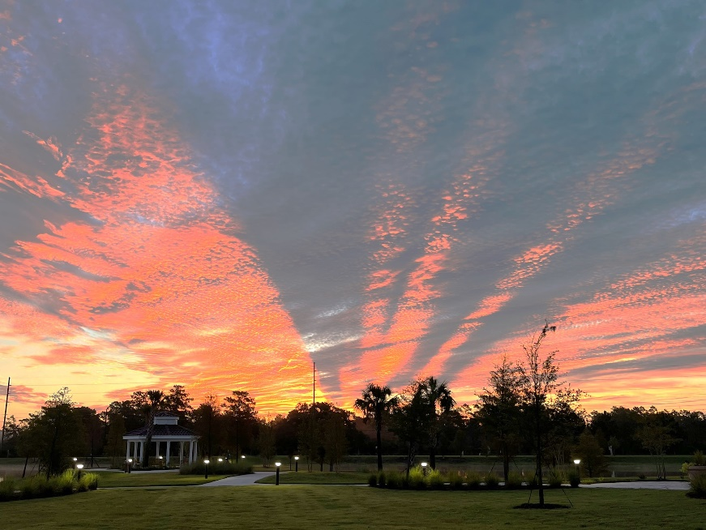

Photo by Vicki Tindall

# OUR FEATURE ARTICLE

**The new UCF bus route by Sal and Mitch Mitchel**

On a cold and wintry morning at exactly 8:15 AM, Monday, January 22, 2024 our intrepid travelers, Sally and Larry Mitchell, set forth on their journey to the Alafaya Trail aboard the newly commissioned "UCF/Legacy Bus", which was on its maiden voyage.

Read what happened next in their own words (Tom Nixon)

**“THINK OUTSIDE THE BUS”**

**--- A Tall Tale of Traveling --- by Sal and Mitch**

Good day, Legacy Pointe! Today —Monday, January 22nd — was the kickoff of our new UCF bus service! Meet Khristopher (Christopher with a “K”!), an engaging and highly experienced ‘gent’ who will be our dedicated five-day-a-week driver.  
  
Today our “ride” is in a dedicated 20-passenger bus that is a very nice, cushy transport. It is a wheelchair equipped with automatic lift. With wheelchairs aboard the bus will accommodate two wheelchairs and 16 passengers. This bus will be on the “run” every day but Tuesday.  
  
On Tuesday the bus that will used will be a larger UCF bus to accommodate riders attending LIFE. This bus will carry 36 passengers; with two wheelchairs it will carry either 28 or 30. Just for your information, all UCF buses are wheelchair equipped.  
  
Our scheduled departure was at 8:15. The first stop on this initial journey was Publix. While stopped there Kristopher did a test “run” of the wheelchair lift at the drop-off point. OK, bad terminology! Not drop off! Rather, “Lift off!.”  
  
After Publix, on to Dollar Tree! Check out the other shops and restaurants in this shopping center. Stop off for shopping and lunch, and then jump back aboard on the next bus a couple of hours later!  
  
Next on the journey is the UCF Health Clinic, the first of two UCF campus stops. During this period Kristopher related some stories from his time as a school bus driver in Colorado Springs, Colorado — especially for middle schoolers. One middle schooler was memorable in that each day when he boarded the bus he would ask some random question. To wit “Have you taught your cat about gun safety?” (Khristopher later finds out that there is a book “How to Talk to Your Cat About Safety: And Abstinence, Drugs, Satanism, and Other Dangers That Threaten Their Nine Lives.”). Such is the life of a professional bus driver!  
  
Next, and final, stop (before getting back to Legacy Pointe, of course) is the UCF Student Union. To and from the Student Union you will have the chance to see some of the UCF campus and its sorority and fraternity row.  
  
We were at each stop along the route for 10 to 15 minutes, depending on traffic. If you are quick and wearing track shoes you MIGHT have time to dash in to buy two bananas or a happy face balloon, depending on location.  
  
We arrived back at Legacy Pointe at 9:55, the end of our expedition - slightly less than a two-hour journey— the initial UCF-Legacy Pointe run! The bus is comfy and Kristopher is engaging and a great tour guide.  
  
Check your bus schedules closely for the “ride-of-the-day” hit list. There are a wide variety of destinations. You might not have a “need” to ride the bus during this three-month trial period, but jump aboard to get off campus, gab and take a look at the world around us without having to take your eyes off the road!

**Brought to you by your “Bus Influencer” Sal and “Curb Reporter” Mitch**  **and bus captainTom Nixon**

**Your New Year’s – Resolutions??? Are They Working**

We are one month plus into our new year. And yes, your L.P. Independent Times is here to remind you – as promised – that you were supposed to make some changes this year to your health and well-being.

Is this going to be hard? You bet, especially if you have not done much for yourself over the last few years or maybe many years.

So, as we get into month number two it is not too late to take a look at our daily routines. Some of us are in our sixties, and many more are far beyond that decade. But there are many years ahead of us all. And we all want to stay safe, and healthy while enjoying the fun times at Legacy Pointe.

Start with some easy stuff: several days a week walk around the building, or stroll outside; talk to a new person each week – you will have 50 new friends come December; don’t just walk by the gym – walk in for a few minutes – try a bike ride or a lite weight machine; and finally, an easy one - check your daily nutrition! Nutrition is an easy one. Just think about it for a minute. We all have fully equipped kitchens. We have a bistro. We now have full menu selections in the dining room at noon and night. We have bus trips to the grocery stores. We have it all in terms of getting the correct nutrition for our health.

Remember each month in our Health and More section we publish Wi-Fi links to articles on Socialization, Exercise, and Nutrition. These are all by experts!

The Tech Corner by Joe Solymossy

**Windows 11**

What about WIN 11 and Microsoft Outlook 2024? On September 21, 2023, Micro Soft announced the availability of the “new” [Outlook for Windows](https://www.microsoft.com/en-us/microsoft-365/outlook/outlook-for-windows?ocid=cmm7wl6xif6) for personal accounts through the [Microsoft Store on Windows 11](https://apps.microsoft.com/store/detail/outlook-for-windows/9NRX63209R7B?ocid=cmmvxm26rjh) and the [Sept. 26 Windows fall update](https://blogs.windows.com/windowsexperience/2023/09/26/the-most-personal-windows-11-experience-begins-rolling-out-today/). It is a free app for Windows users designed to help you easily connect and coordinate your various email accounts and calendars in one place. It is intended to take advantage of the latest trends in Artificial Intelligence (AI). You will be able to write clear concise emails and get intelligent suggestions with built-in AI, seamlessly and securely attach important documents and photos to any note, and access OneDrive files and Office web apps without a subscription.   S[ome current devices upgrading to Windows 11](https://blogs.windows.com/windowsexperience/2023/09/26/how-to-get-the-latest-windows-11-innovations/) and newly purchased Windows devices running Windows 11 will have the “new” Outlook pre-installed.

The “new” Outlook for Windows will include email and a calendar for each different email account. It will be free (with ads) for everyone with a Windows account and will replace all Windows Mail, Calendar, and People apps by the end of 2024. The “new” Outlook for Windows is designed to run on all Android and Apple products.

February 20th, the third Tuesday of the month we will start a tech class. Sometimes it will be a class about how to use your iPhone. Sometimes it will be information about how “Scammers and Hackers” operate. We will also try to get a demonstration of one of the many new AI products coming to market. February 20th will be an in-depth review of the “new” Outlook for Windows. This class is for you if you are currently using any MS mail or calendar product.

**When Pickleball Comes to Legacy Pointe by Graham Ricks**

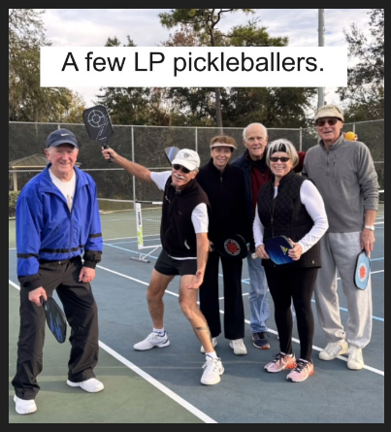In the September issue of this newsletter, we explained Why Pickleball is coming to Legacy Pointe. In case you missed it, you can find it on page 7 of that newsletter by clicking [HERE](https://lpresidentsonline.org/newsletters/LP%20Newsletter%20September%202023.pdf).

As we eagerly anticipate the construction of our very own pickleball courts, this article will catch you up on the progress made to date and make a prediction of When Pickleball will arrive at Legacy Pointe. Let's look at the details of securing the required county permits and uncover the timeline.

In the first week of January 2024, Bert Francis, the CCRC Development Corporation board chairman, signed the Seminole County Planning and Development Department initial application forms, marking a successful start to the process.

On January 24, a significant milestone was reached when the St. Johns River Water Management District issued the permit for the stormwater engineering component of our application.

The current permitting phase involves thorough reviews and recommendations from various county departments, including Planning and Development, Public Safety/Fire Marshal, and Public Works. By February 17, we can expect recommendations and comments to be relayed to the county’s Project Manager.

The issuance of the construction permit is estimated to take 60 days if no modifications or changes are needed after the February 17 review. In case any adjustments are necessary, our engineer will swiftly address them to ensure a seamless continuation of the process.

Excitement is building as AAA Court Construction, our chosen contractor, has expressed readiness to start construction with minimal notice. The estimated cost for the project is $52,400. The funds to build the courts have been donated by members of the Legacy Pointe Pickleball Club, showcasing their commitment and enthusiasm to bring our courts to life.

Once construction commences, our pickleball courts should be ready for play this summer. As we inch closer to completion, we'll collectively decide on the paint colors for the courts, allowing us to infuse our community spirit into this exciting project.

Bonus note: “ Mayo Clinic Study Suggests Pickleball Contributes To Longevity.”

Recent peer-reviewed studies linking racket sports to healthy longevity are particularly relevant to the senior population. A[Mayo Clinic study](https://www.mayoclinicproceedings.org/article/S0025-6196(18)30538-X/fulltext) found that playing racket sports increased the life expectancy of participants by between 6 and nearly 10 years.  Pickleball requires balance, coordination, and mental agility. Socializing while playing these sports likely enhances the known benefits of exercise. These results align with previous large studies published by The Journal of the American Medical Association, the Copenhagen City Heart Study, and The British Journal of Sports Medicine. Read more by clicking [HERE](https://pickleballunion.com/pickleball-longevity/).

**The Future Looks Promising For a**

**Relationship between Legacy Pointe at UCF and the Rosen School of Hospitality**

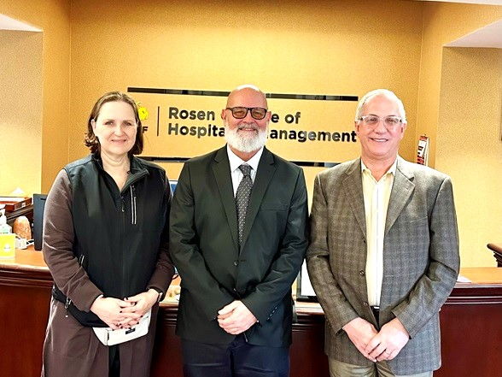

Dining Services Director Taylor Ebersole at Rosen College

We had a wonderful week at Legacy Pointe at UCF filled with resident council meetings, happy faces and a meeting this afternoon with the UCF Rosen School of Hospitality Interim Dean and several members of her team.  Today's meeting followed a visit to the School by Dining Services Director Taylor Ebersole earlier this week (see photo above) We're planning some exciting partnerships. These will include offering our residents a chance to take part in the Rosen Leadership Series presentations, potential presentations here from Rosen staff, and an exciting research project the university wants to do with our residents regarding senior living food and beverage services!  We'll be sharing more details in the future about that. They're so excited to work with you!

**Students from Haggerty H.S. on Investing**

**What do High School students know about investing in the Stock Market and in other places?**

Well as it turned out plenty. Students from the Haggerty High School Investment Club arrived at Legacy Pointe on Sunday, January 14th at 9 A.M. to discuss investing and especially for future retirement.

Wow! Whoever thought that high school students would be up at 9 AM, especially on Sunday! Well, a friend of L.P. resident Bill Maltifano is a teacher and also ran the investment club. Bill gathered residents Steve Keogh, an international banker, and day trader, along with investors Carolyn Ruhe and Frank Russo. For over 2 hours they discussed investing – all sorts- except bitcoins. They asked many questions and understood most of what was being said.

**Beekeeper Visits Garden Club**

The Legacy Pointe Garden Club invited a Beekeeper to talk to club members and all residents about the history of bees in America and how important they are in the growing of our food.

The presentation was made by Beekeeper, Winfridus Bakker on Monday, January 22nd in the Card Room.

The talk lasted over an hour. Win spoke and answered many questions. He accompanied his talk with 30 slides that documented every phase of bee life from the creation of the Queen Bee, management of the hive, the responsibility of the different types of bees in each hive, their importance to ensuring our food supply, and the kinds of honey they produce.

**“Look Out Below”**

This is how some of our residents felt as the looked at a giant crane lifting a large air handler of the Legacy Pointe Independent Living apartments.

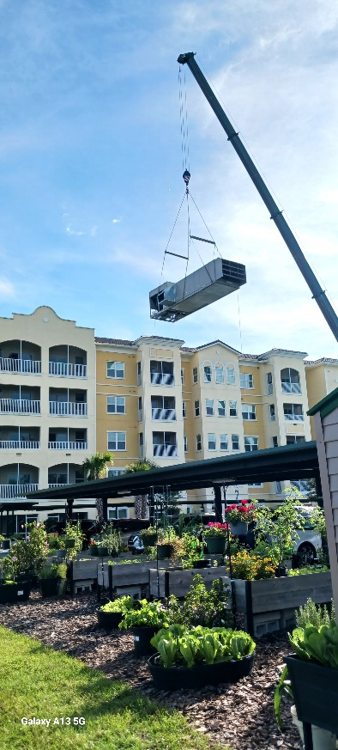

Photo by Phyllis Milmore

This was one step in a month long project to repair some construction problems and insert some sound dampers under the unit so that each time it was called into operation during the day it would not sound like a ‘jet’ taking off. The fifth-floor residents are thankful that it is a little quieter.

## L.P. RESIDENT TOPICS AND OPINIONS L.P. RESIDENT EDITORIALS

## RECYCLING by Frank Russo

This topic has been raised on and off since we moved into L.P. in March of 2022. The Men’s Group representatives met with the former Executive Director, Domenica Wehmann, on the subject of recycling. Domenica said that she had looked into the issue of recycling with the County and was told that they looked upon Legacy Pointe as ‘private property’ and would not send the trucks into L.P.

This explanation by the County as reported by Domenica seemed a bit ‘lame’ since in many Counties in Florida trucks are sent into ‘gated’ communities to collect recyclables. Are these ‘gated’ communities also ‘private property’?

That issue aside we should look at the whole process of recycling and what can be recycled. Obviously ‘gold’ and ‘silver’ are great for recycling, resulting in a significant increase in our pocket change. But in this article, we will look at materials that we go through every day to see what can be done about recycling.

**Good News** - There is still a strong recycling market for Cardboard and Aluminum cans.

, **Paper** – Newspaper recycling has increased from 21.3 percent in 1980 to 68.2 percent in 2018. Used paper has many uses in a new life and requires far fewer resources to change its original footprint.

After that recycling centers are very selective.

**Plastic** - Let’s start with “plastic”. According to National Geographic, only 6% of all plastic in the U.S. is recycled each year. Of the 40 million tons of plastic waste generated in the United States last year, only five to six percent—or about two million tons—was recycled, Even China does not want our plastics. So, plastic is populating our planet's landfills and oceans faster than our human population grows.

Plastic bottles are one part of the ‘plastic problem’ but some of these can be recycled. The biggest problem is single-use plastic such as grocery bags, and plastic wrapping on everything from meat, produce, baked goods, etc.

What can we at Legacy Pointe do regarding recycling? Here are some suggestions:

1. Make sure we are recycling all cardboard. It cannot be sent down our rubbish bins. Cardboard is collected separately. What happens to it at L.P.? Is it being recycled?
2. What can we do with our newspapers? They have a value on the recycling market
3. We should support anyone who collects aluminum cans for recycling! **(See the article below from Mitch Mitchell)**
4. Take your own bags to the grocery store. This will help immensely!
5. Plastic drink bottles are a major problem. They can be recycled but nobody wants to collect them. In Massachusetts where I come from there is a State ‘bottle law’. Every drink bottle and some others have a deposit placed on them when sold. When a customer returns the bottle to the place of purchase they get a refund. The place of purchase has recycling machines that reduce the bottle to pellets and these can be sold to companies that recycle drink bottles. Some people are bottle collectors for a profit. You will never see a plastic drink bottle on the street.
6. Reduce our dependence on plastic rather than recycling plastic.

**Recycling Preview Article by Mitch Mitchell**

“In mid-October last year, a couple of residents kicked off a trial for recycling aluminum cans from the main dining room and Bistro. The staff responded enthusiastically and about 1,100-1,200 cans a month are being recovered. VERY shortly this recovery effort will extend to the IL building using the floor trash rooms and the cart room on the 1st floor near the door exit to parking. In addition, a similar effort will also start for the recovery of dangerous LITHIUM batteries.  More detailed information on both is forthcoming (or maybe are already “out there” by the time you read this)!

To make these recovery efforts work, volunteers will be needed: it won’t require much time on a weekly basis, but it will be “steady work” on a continuing basis. As always, “many hands make light work.”  If you would like to assist with this effort after looking at the detailed information being distributed about this program, please send an email to Larry (Mitch) Mitchell [[skykingsky@aol.com](mailto:skykingsky@aol.com)] or Ross Williams [[rwnole2@gmail.com](mailto:rwnole2@gmail.com)]. Thanks!”

**More Next Month on Recycling** including what can be done with plastic? – Some African Countries have found a real solution! And we are eating ‘plastic’ what is it doing to us?

Sign up for the **LP Residents Forum**: [**https://lpresidentsonline.org/smf**](https://lpresidentsonline.org/smf/index.php)  **You can easily set up your login and password.** TheForum is a place for you and your neighbors to come together . . . To create a knowledge base . . . To go beyond a community to becoming a family. We hope to see you online soon. If you need help contact by email Jonathan or Ina.

Email Jonathan at 47ipsd@gmail.com or Ina at utgrad@attglobal.net.

**Tis the Season for ???**

**For Wind, Rain, Hail, … Stop! Wait! This is Florida. It doesn’t happen here!**

Well, Surprise! It did happen here. On Sunday, February 4th just past supper time. It was very quiet – and – then the weather radios went frantic with calls of impending doom. But we in Florida are used to these reports and our life goes on. But – guess what? This time the weather radios were correct. We got hit. First with rain and suddenly every window in the building became a sonic drumroll as the rain changed to ’ice drones’ exploding on our glass. Our only line of defense was our window blinds. Image blinds, they are no match for ‘ice drones’. Fortunately, the wind that launched the drones moved swiftly onto its next target. We were safe inside and were spared. Vehicles left in the open were not so fortunate. Roofs and hoods may have some battle scars.

The whole scenario was captured with numerous photos of the event by Ann Kirkendall, who heroically braved the elements to capture the event documenting the drone attack. Below are several of her pictures. We will probably save some to print in July when the heat index hits 110 degrees.

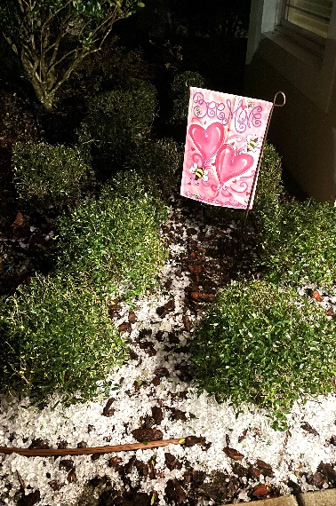 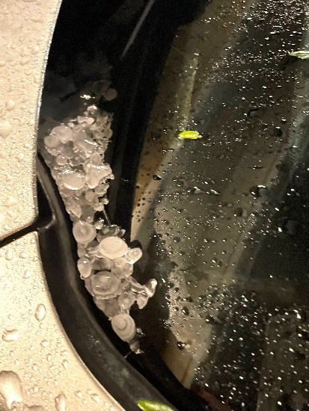 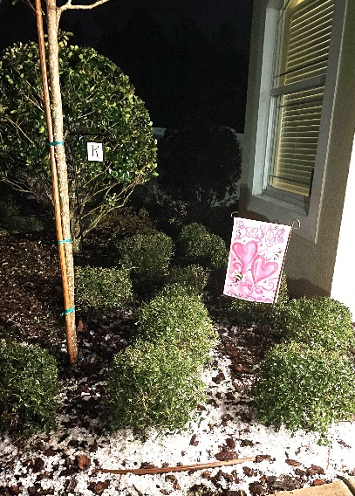

Ann Kirkendall Ann Kirkendall Ann Kirkendall

## HEALTH AND MORE

## Social, Physical, and Nutritional aspects of ‘senior living’.

**Each month, here are articles about social fitness, physical fitness, and nutritional fitness. They are for your interest. We do not make any claims or recommendations.**

|  |  |  |  |  |  |
| --- | --- | --- | --- | --- | --- |
| **Social Fitness:** Have you nurtured your ‘social fitness’. This is one of the topics in a new article in Forbes Magazine entitled ‘I Don’t Want To Be Old When I’m Old’—Defining Healthy Longevity  |  |  | | --- | --- | | |  | | --- | | Here is a link to the article:https://mail.google.com/mail/u/0/images/cleardot.gif | |   <https://www.forbes.com/sites/stevevernon/2023/11/07/i-dont-want-to-be-old-when-im-old-defining-healthy-longevity/> |  |  | https://mail.google.com/mail/u/0/images/cleardot.gif  https://mail.google.com/mail/u/0/images/cleardot.gif  https://mail.google.com/mail/u/0/images/cleardot.gif |

**(hold the control key and click on the link or copy it and paste it into your browser).**

**Physical Fitness**

What is the Goldilocks Standard for physical activity? Too little, too much, just right. So to figure it all out we have to turn to studies. One of these asks the question

**“How much should you exercise for a longer, healthier life? Study offers clues”**

Read it and judge for yourself

<https://www.medicalnewstoday.com/articles/how-much-exercise-for-longevity-healthier-life#Longevity:-Exercise-may-not-be-a-factor-on-its-own>

**(hold the control key and click on the link or copy it and paste it into your browser).**

**Nutritional Fitness :**



Are Scientific Studies done in England valid in America? This one about changing your diet can add years to your life is one such study Take a look at the article below.

|  |  |
| --- | --- |
| |  | | --- | | https://mail.google.com/mail/u/0/images/cleardot.gif | |

<https://www.sciencealert.com/you-can-add-10-years-to-your-life-simply-by-changing-your-diet-massive-study-finds>

**(hold the control key and click on the link or copy it and paste it into your browser).**

**DO YOU NEED TO GET OUT AND DO SOMETHING?**

***Check out these possibilities:***

**IF YOU DO NOT WANT TO GO OUT, BELOW ARE OPPORTUNITIES IF YOU STAY IN.**

**CHECK OUT TOUCH TOWN JOIN A CLUB**

Check out Touch Town on your phone. There are over a dozen clubs here at Legacy Pointe that would love to have you join. Also in the Card Room there are many activities each day some starting at 7 AM

Here are just a few available The Legacy Pointe Book Club, Garden Club, Chess Club, and many others. Check Touch Town for dates and times of many others.

**The L.P. Book Club - February 2024:** We invite you to come to the meeting of the Legacy Pointe Book Club on Tuesday, February 20, 2024, at 3 PM in the Card Room.

***Our Book for February is called*  Lessons in Chemistry by Bonnie Garmus**



#1 NEW YORK TIMES BESTSELLER \* GMA BOOK CLUB PICK \* Meet Elizabeth Zott: "a gifted research chemist, absurdly self-assured and immune to social convention" (The Washington Post) in 1960s California whose career takes a detour when she becomes the unlikely star of a beloved TV cooking show. \* APPLE TV+ SERIES COMING LATER THIS YEAR (from Amazon)

This novel is "irresistible, satisfying and full of fuel" (The New York Times Book Review) and "witty, sometimes hilarious...the Catch-22 of early feminism" (Stephen King, via Twitter).

Remember We invite you to come to the meeting of the Legacy Pointe Book Club on Tuesday, February 20, 2024, at 3 PM in the Card Room.

# *Our Book for March is called* The Personal Librarian: A GMA Book Club Pick

by [Marie Benedict](https://www.amazon.com/Marie-Benedict/e/B01EX8MYO4/ref=dp_byline_cont_ebooks_1) (Author), [Victoria Christopher Murray](https://www.amazon.com/Victoria-Christopher-Murray/e/B001IO9LP2/ref=dp_byline_cont_ebooks_2) (Author)



A remarkable novel about J. P. Morgan’s personal librarian, Belle da Costa Greene, the Black American woman who was forced to hide her true identity and pass as white in order to leave a lasting legacy that enriched our nation, from New York Times bestselling authors Marie Benedict and Victoria Christopher Murray. (from Amazon)

**March 2024:** We invite you to come to the meeting of the Legacy Pointe Book Club on Tuesday, March 19, 2024, at 3 PM in the Card Room.

## SPACE LAUNCHES AT KENNEDY SPACE CENTER FOR JANUARY 2024



## Photo by Joyce Swing

## For list of all launches, check this website

[**Space calendar 2024: Rocket launches and sky watching dates**](https://www.space.com/32286-space-calendar.html)

**Feb. 9:**The moon will be at its closest point to Earth in orbit — but unfortunately, this "supermoon" will be too close to the sun to be visible to sky watchers on the ground. Despite its proximity to Earth, sky watchers won't be able to see the moon, because it will be a new moon. It will be too near to the sun to be seen, and will be invisible as it passes across our daytime sky.

## SURFING THE INTERNET

You could spend your whole day just sitting and surfing. If you do this your entire body will fall apart from lack of exercise. So, our newsletter is asking its readers who spend just a few minutes a day surfing to send along some links to articles that may be interesting or funny or extremely important. Send links to Frank Russo at frankrusso2012@gmail.com

**Below are several examples of interesting web surfing’s**

**Article submitted by Resident Ida Cobb**

**ORLANDO, Fla.** – At age 16, most kids are thinking about getting their driver’s license or making **[TikToks](https://www.tiktok.com/@wkmg_news6" \t "_blank)**, except for Tiffani Gay, who is focused on changing the world with her award-winning invention.

<https://www.clickorlando.com/podcasts/2024/01/29/orlando-teen-invents-device-with-potential-to-help-22-billion-people/>

**(hold the control key and click on the link or copy it and paste it into your browser).**

Another ‘dumb’ tourist at Yellowstone National Park

All visitors to [Yellowstone National Park](https://www.advnture.com/features/yellowstone-facts) are warned to give the animals plenty of space, but sometimes that advice goes in one ear and out the other, as one tourist recently demonstrated. Ignoring [official advice not to pet the fluffy cows](https://www.advnture.com/news/national-park-rangers-beg-hikers-not-to-pet-yellowstones-fluffy-cows), the man approached a particularly large bison and asked if he could stroke its fur. Excited, he then asked whether he could ride it before being startled back by the animal's bristling reaction.

<https://www.yahoo.com/lifestyle/yellowstone-tourist-learns-trying-ride-105454754.html>

**(hold the control key and click on the link or copy it and paste it into your browser).**

# Are Humans Still Evolving? 'Maybe More Rapidly Than Ever,' Says Scientist

<https://www.newsweek.com/humans-evolving-rapidly-ever-scientist-evolution-genetics-1852884>

**(hold the control key and click on the link or copy it and paste it into your browser).**

**Our Days End – Sunset over Legacy Pointe at UCF**



**By Phyllis Milmore**

Feedback? Stories? Photos?

Send to Frank Russo at frankrusso2012@gmail.com

REMEMBER sign up for the **LP Residents Forum**: [**https://lpresidentsonline.org/smf**](https://lpresidentsonline.org/smf/index.php)  **You can easily set up your login and password.** TheForum is a place for you and your neighbors to come together . . . To create a knowledge base . . . To go beyond a community to becoming a family. We hope to see you online soon. If you need help contact by email Jonathan or Ina.

"And in case you missed any issues, click the following link to access the complete Newsletter Archive:"

[LP Residents Forum - Residents Newsletters **(lpresidentsonline.org**)](https://lpresidentsonline.org/newsletters/newsletters.html)

Email Jonathan at 47ipsd@gmail.com or Ina at utgrad@attglobal.net.